Wazuh Manager VM Setup on Windows Host & Endpoint Policy Configuration

Wazuh Manager VM Setup on Windows Host & Endpoint Policy Configuration

Initial Setup – Deploying the Wazuh Manager Virtual Machine

Step 1: Importing the Wazuh OVA File into VirtualBox
- Download the Wazuh OVA file from the official Wazuh website.
Once the download is complete, the file will be located in the Downloads folder on the Windows host operating system.
- Open Oracle VirtualBox on the Windows host machine.
- Click on File, then Import Appliance.
- Select the downloaded wazuh.ova file and click Next.
- Configure the virtual machine hardware specifications as follows:
  - Memory (RAM): 4 GB
  - CPU: 4 vCPUs
  - Storage (Hard Disk): 50 GB
- Review the appliance settings and click Import to begin the VM deployment.
- Wait for the import process to complete successfully.

Step 2: Network Configuration (Recommended)
- Select the newly imported Wazuh VM in VirtualBox, right click on it.
- Click Settings Network.
- Set Adapter 1 to one of the following (depending on your lab needs):
  - NAT (easy internet access)
  - Bridged Adapter (recommended for agent communication and GUI access from host)
- Then save the configuration.

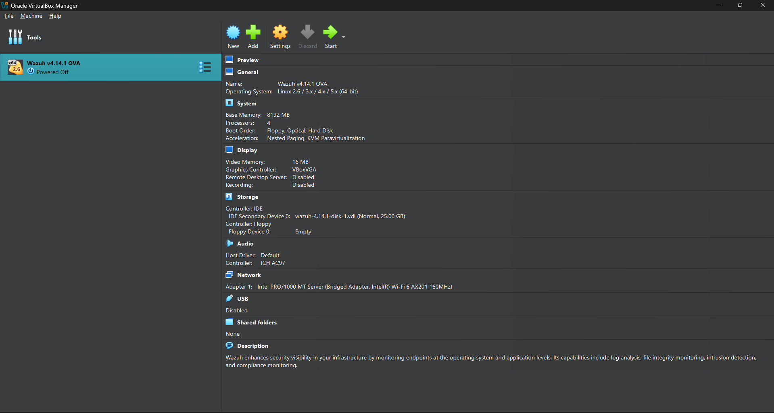

Step 3: Start the Wazuh Manager VM
- Click start to power on the Wazuh VM.
- Allow the system to boot completely.
- Log in using the default credentials provided by Wazuh.
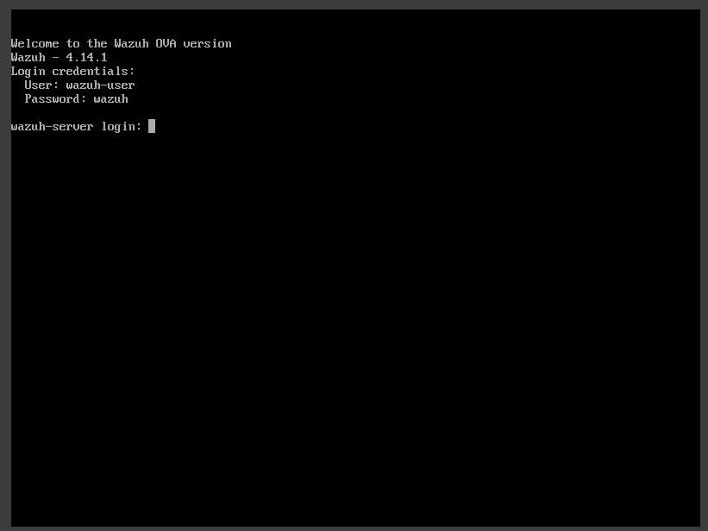

Step 4: Logging In and Retrieving the Wazuh VM IP Address
- After completing the import process, click Start in VirtualBox to power on the Wazuh Manager virtual machine.
- Allow the system to boot fully.
Once the login screen appears, enter the username and password displayed on the VM screen.
- After successfully logging in, access the terminal.
- To retrieve the IP address assigned to the Wazuh VM, run the following command: Ip a
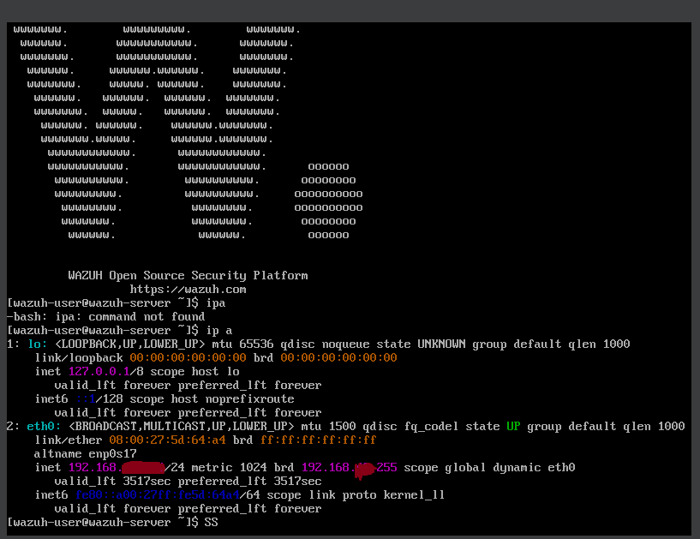

Agent Installation on the Windows Endpoint
- After retrieving the IP address of the Wazuh Manager VM, open a web browser on the Windows host machine.
- Enter the Wazuh Manager IP address into the browser address bar using HTTPS:
- When the Wazuh web interface loads, log in using the default Wazuh dashboard credentials.
- After successful authentication, the Wazuh Dashboard opens on the Overview page.
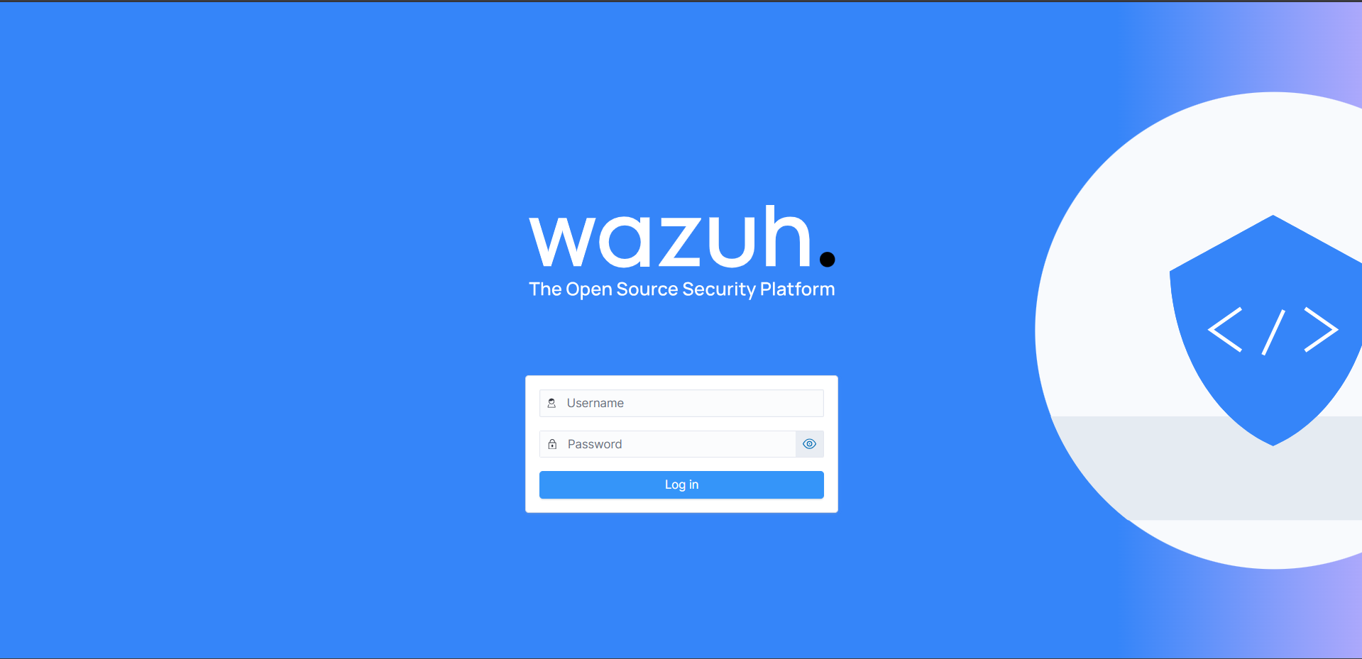

Enrolling the Windows Host as a Wazuh Agent
- From the Wazuh Dashboard, navigate to:
  - Menu > Agent > Summary
- Click Deploy new agent.
- In the agent deployment window:
  - Select Windows as the operating system.
  - Enter a name for the agent (for example, the host PC name).
  - Specify the IP address of the Wazuh Manager server.
  - Confirm the agent group if required (default group can be used).
- The dashboard generates installation commands and instructions specific to the Windows endpoint.
- Copy the provided commands and run them on the Windows host machine using Command Prompt or PowerShell with Administrator privileges.
- Follow the on-screen instructions to complete the agent installation and registration process.

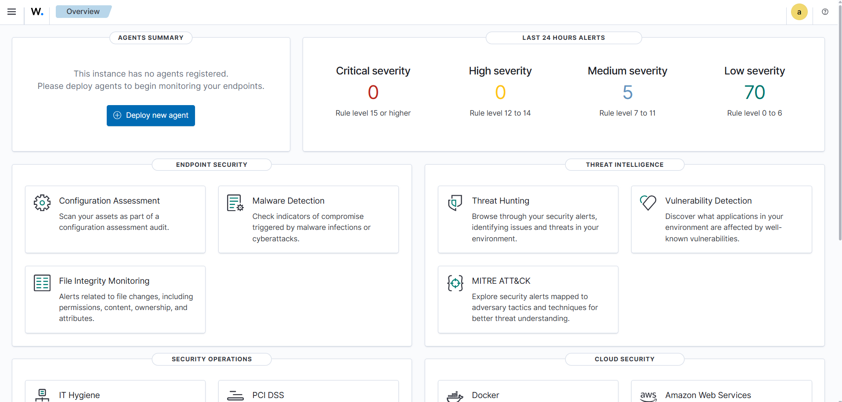
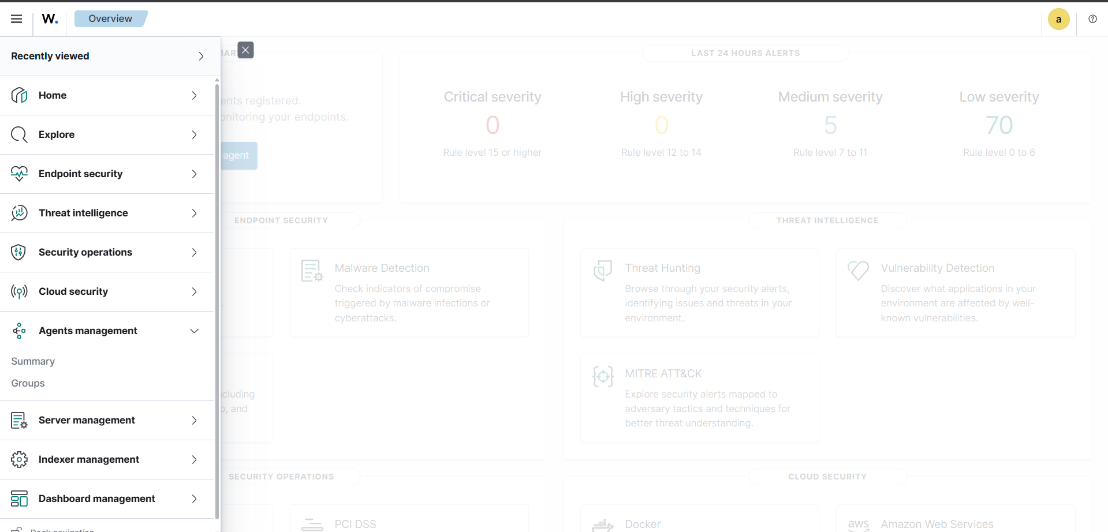
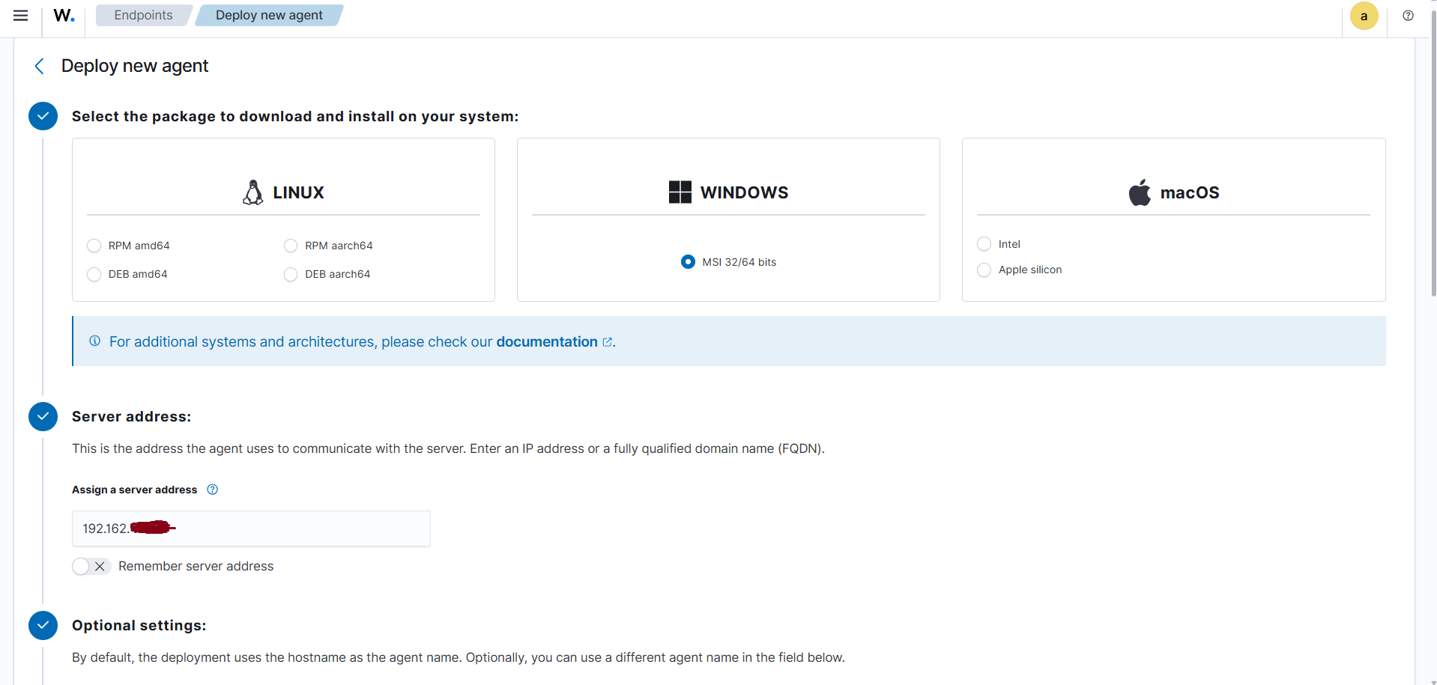
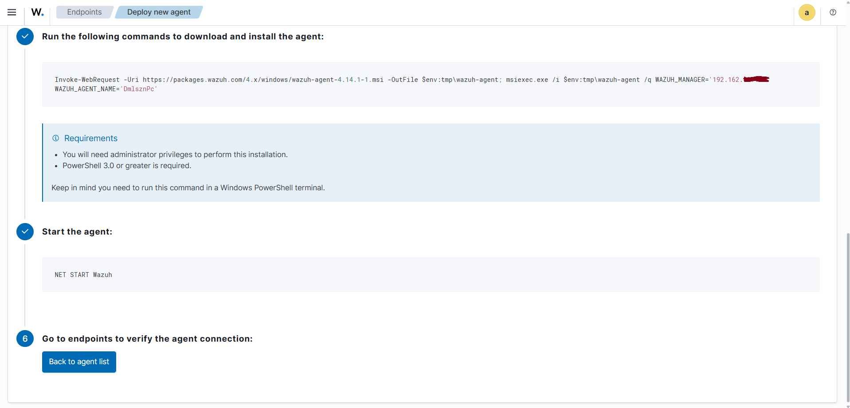
- After installation, return to the Wazuh Dashboard.
- Confirm that the Windows host now appears in the Agents Summary with a Connected status.

Policy Configuration – File Integrity Monitoring (FIM)
After successfully deploying the Windows host PC as a Wazuh agent, the next step is to configure File Integrity Monitoring (FIM) to monitor a specific file on the endpoint.
In this lab, a text file named altschool test.txt was created on the Windows host and stored in the Documents directory.

Step 1: Locate the Wazuh Agent Configuration File
- On the Windows host machine, navigate to the Wazuh agent installation directory:
C:\Program Files (x86)\ossec-agent\
- Locate the ossec.conf file.
This file is the main configuration file for the Wazuh agent.
- Open Notepad as Administrator, then open the ossec.conf file from within Notepad.
(Administrator privileges are required to save changes.)

Step 2: Configure the Syscheck (FIM) Rule
- Inside the ossec.conf file, locate the <syscheck> block.
- Add the following rule inside the <syscheck> section to enable real-time monitoring of the Documents directory:
<directories check_all="yes" realtime="yes">
C:\Users\User\Documents
</directories>

Step 3: Adjust the Scan Frequency
- Still within the <syscheck> block, locate the <frequency> setting.
- Modify the value to reduce the scan interval to 60 seconds, allowing faster detection of changes:
- <frequency>60</frequency>
This ensures the syscheck scan runs every minute, making the monitored file changes visible more quickly in the Wazuh Dashboard.

Step 4: Save and Apply the Configuration
- Save the ossec.conf file.
- Restart the Wazuh agent service on the Windows host to apply the changes.
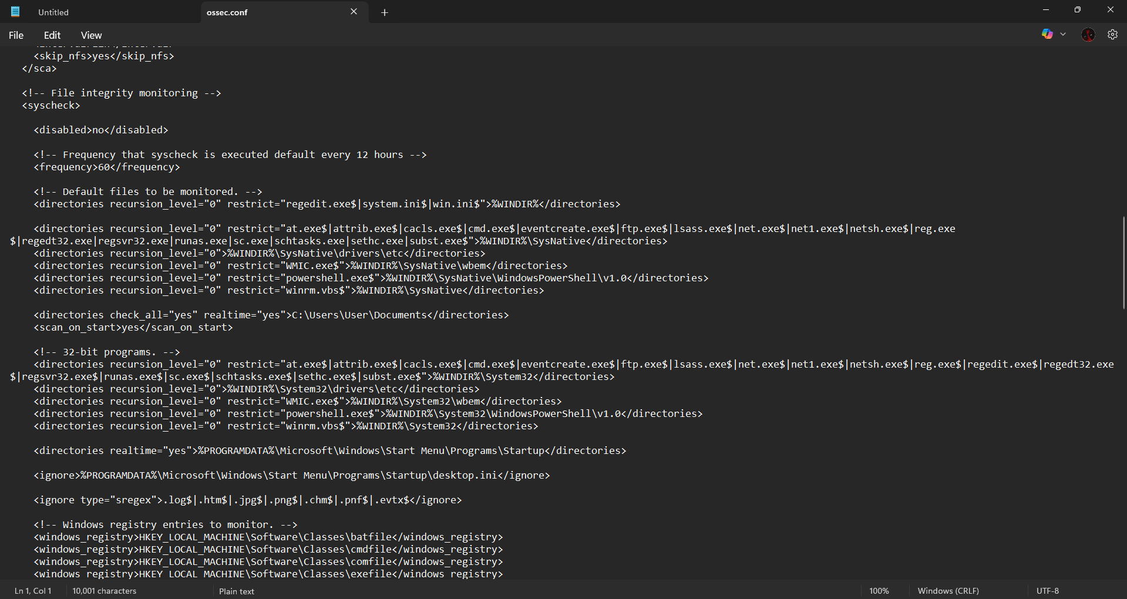

Applying the FIM Configuration and Restarting the Wazuh Agent
After editing and saving the ossec.conf file on the Windows endpoint, the Wazuh agent service must be restarted for the new File Integrity Monitoring (FIM) policy to take effect.

Step 1: Identify the Wazuh Agent Service Name (Required)
Before restarting the agent, you must confirm the exact service name used on your Windows system.
- Open PowerShell as Administrator.
- Run the following command to list Wazuh-related services:
Get-Service | Where-Object { $_.Name -like "*wazuh*" -or $_.DisplayName -like "*wazuh*" }
- Note the service name (commonly WazuhSvc).

Step 2: Restart the Wazuh Agent Service
- Restart the Wazuh agent service using the correct service name:
Restart-Service -Name "WazuhSvc"

Step 3: Verify Agent Service Status
- To confirm that the Wazuh agent is running, execute:
Get-Service -Name "WazuhSvc"
- Ensure the Status shows Running.

Step 4: Validate Changes in the Wazuh Dashboard
- Refresh the Wazuh Dashboard in your web browser.
- Navigate to one of the following sections to verify the monitored file:
Inventory > Files
- Confirm that the newly monitored file (e.g., altschool text.txt) appears and that file modification events are being logged.

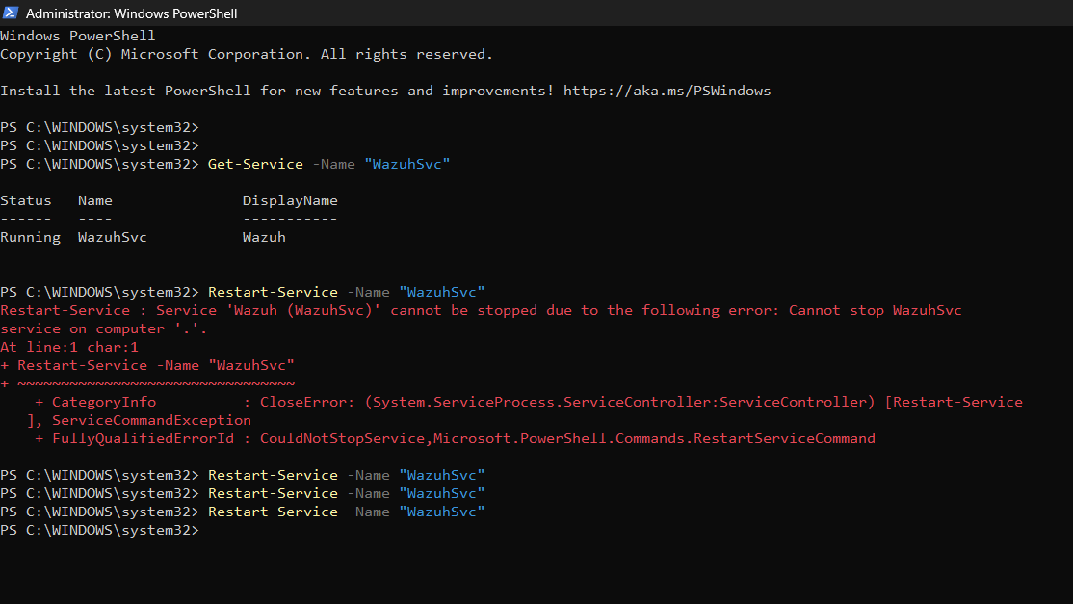

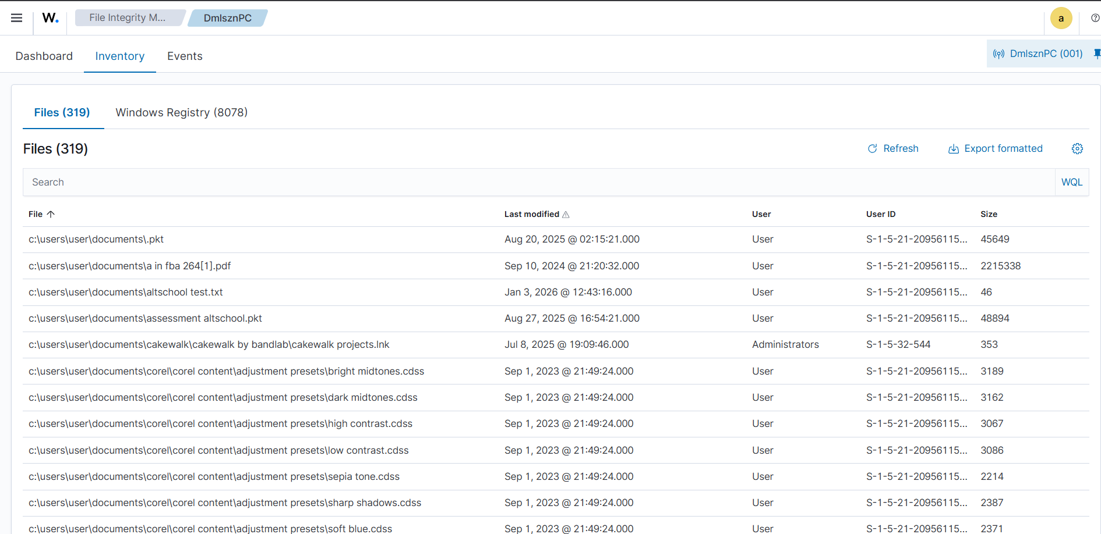
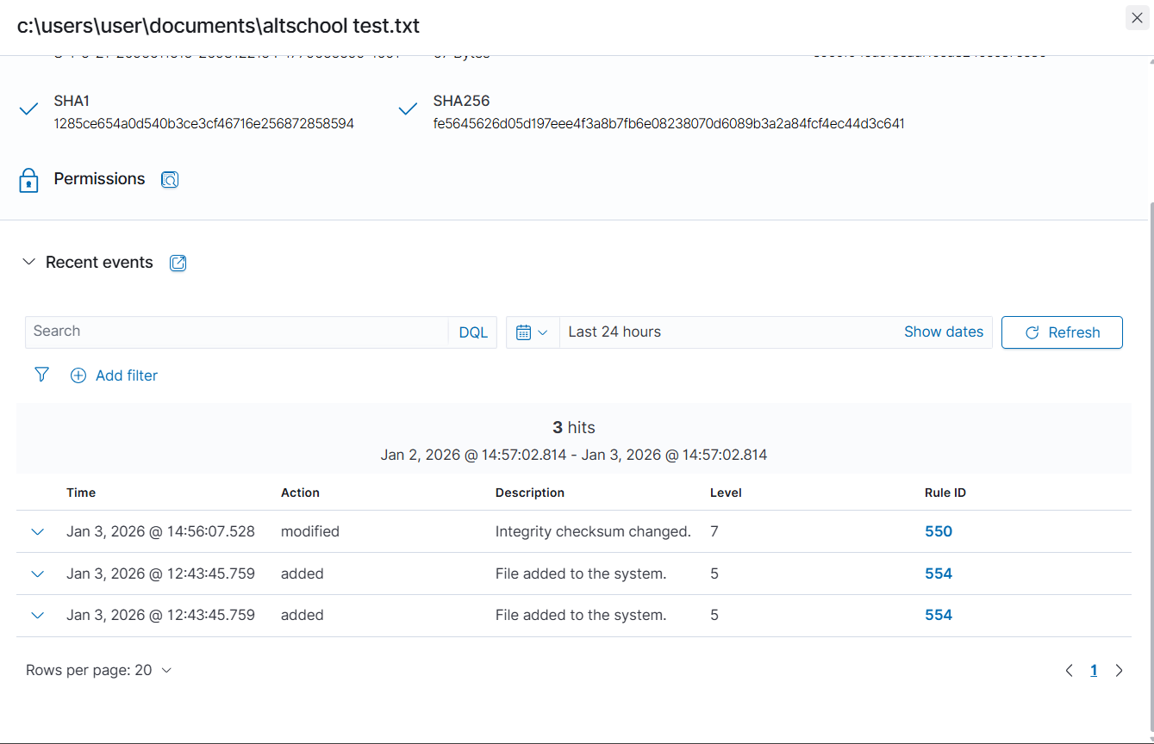

Checking GDPR & PCI DSS Compliance

In the Wazuh dashboard, navigate to Security Operations and select Regulatory Compliance.
From there, choose a compliance standard such as GDPR or PCI DSS.
Selecting a standard opens a dedicated compliance dashboard that displays a breakdown of specific requirements, showing which controls have been met or violated based on alerts generated by the Windows agent.
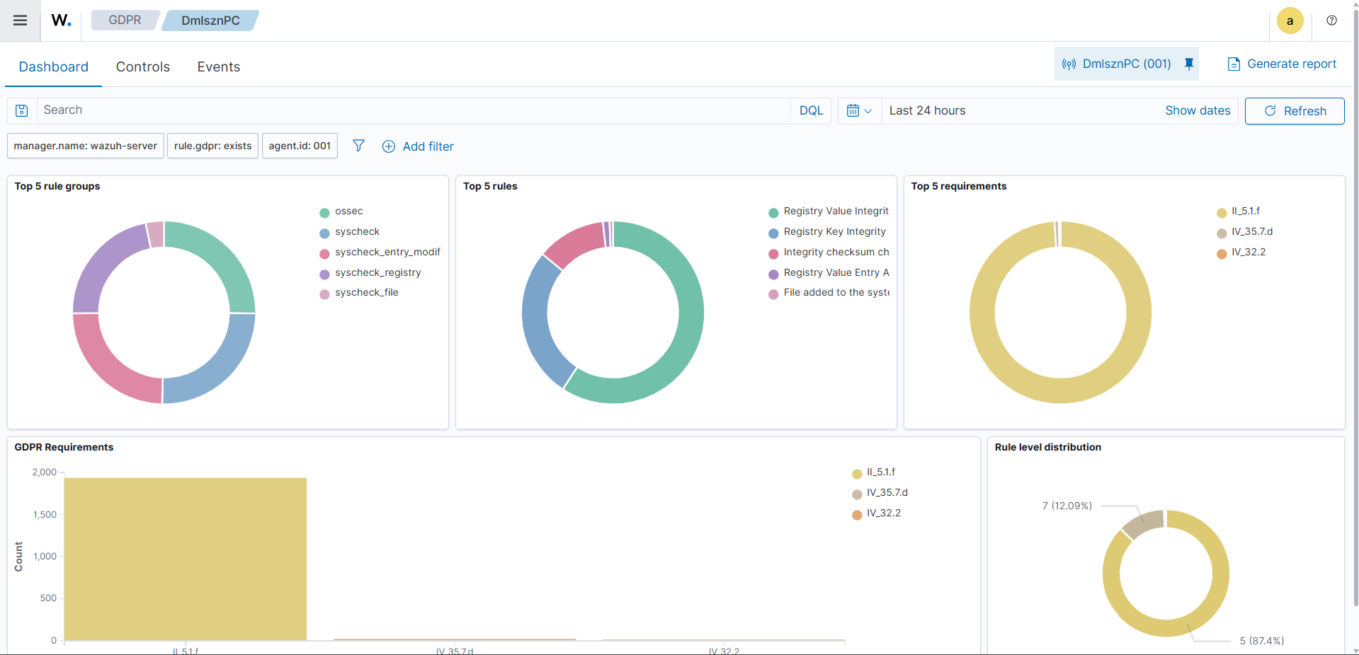

Filtering Security Events by Regulation

To view raw security alerts related to a specific compliance regulation, you can manually filter events in the Discover tab

First, navigate to Explore > Discover.
Click on the search bar and apply one of the following filters:

For GDPR: type rule.gdpr: * and press Enter

For PCI DSS: type rule.pci_dss: * and press Enter

The results will update to display only security events that are mapped to the selected compliance standard.
